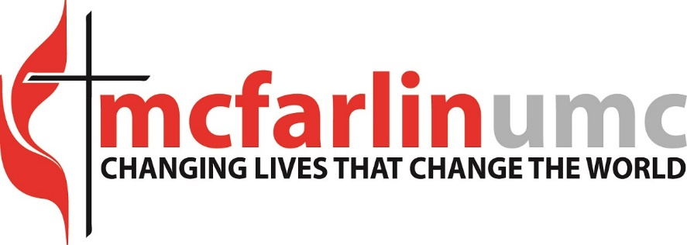
Director of Early Childhood Ministries, McFarlin Memorial United Methodist Church- Norman, OK
McFarlin Memorial United Methodist Church’s mission is to Change Lives that Change the World. We seek persons who will live out our staff values of faith, integrity, openness, courage, compassion, accountability, resilience, patience and excellence.
McFarlin also recognizes that God made all creation and saw that it was good. As a diverse people of God who bring special gifts and evidences of God's grace to the unity of the Church and to society, we are called to be faithful to the example of Jesus' ministry to all persons. As a church that values the participation of all people at all levels of ministry, McFarlin seeks to be a place where all persons are open, welcoming, fully accepting, and supporting of all other persons, enabling them to participate fully in the life of the church, the community, and the world.
We are seeking a Director of Early Childhood Ministries to oversee and coordinate all Early Childhood Ministries for members and guests of McFarlin Memorial UMC, which includes children from infants through Kindergarten, so that they grow as disciples of Jesus Christ and know God’s love for them.
Responsibilities include:
- Make disciples of Jesus Christ for the transformation of the world
- Create and oversee opportunities for spiritual and personal growth for young children
- Provide congregational care to children, as well as to parents and families of young children
- Recruit and equip staff and volunteers to lead programs and activities
- Lead devotionals and spiritual formation opportunities for parents of young children
Qualifications:
- Passion for working with young children and their families
- Strong organizational skills
- Ability to communicate well in group settings with people of different ages
- Commitment to working as part of a team and supporting the mission of the church
- Proficiency in the use of all Microsoft Office applications, email, and online video conferencing
- Available to work on Sundays and some Saturdays
This is a part-time, exempt position and reports to the Director of Children and Families Ministries. McFarlin seeks a person who is relational, organized, efficient, collaborative, motivated and gifted in leading children in faith formation to join our team in carrying out God’s mission to Change Lives that Change the World. McFarlin Memorial United Methodist Church offers competitive compensation and benefits. To apply, please send resume and cover letter to the Rev. Wendi Neal at wneal@mcfarlinumc.org.

