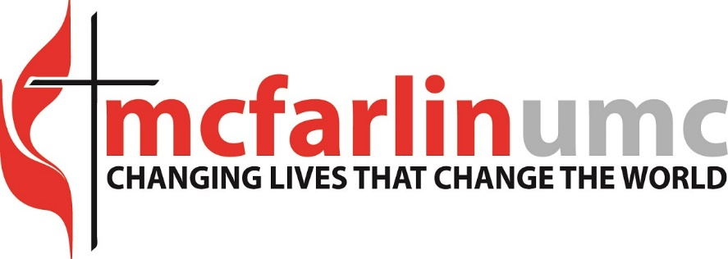
Director of Youth and Children Choirs
McFarlin Memorial United Methodist Church’s mission is to Change Lives that Change the World. We seek persons who will live out our staff values of faith, integrity, openness, courage, compassion, accountability, resilience, patience and excellence.
McFarlin also recognizes that God made all creation and saw that it was good. As a diverse people of God who bring special gifts and evidences of God's grace to the unity of the Church and to society, we are called to be faithful to the example of Jesus' ministry to all persons. As a church that values the participation of all people at all levels of ministry, McFarlin seeks to be a place where all persons are open, welcoming, fully accepting, and supporting of all other persons, enabling them to participate fully in the life of the church, the community, and the
We are seeking a full-time or 2 part-time staff for the Director(s) of the Youth and Children Choirs to be a part of the music ministry team. As stated, this position could be offered as 2 part-time positions depending on interest and qualifications.
Job Specific Responsibilities
- Plan and coordinate with pastors and staff appropriate youth and children’s choir music for worship
- Regularly recruit and communicate with choir members and parents of youth and children choirs
- Prepare weekly rehearsals for the Youth Choir (6-12 grades) and Children’s Choirs (K-1, 2-3, and 4-5 grades) to lead worship regularly at the appropriate services
- Organize annual summer Youth Choir tour (10 days) which includes fundraising activities.
- Oversee and assist with Chapel Choir gameday parking operations for the University of Oklahoma Football games.
- Possible directing other choirs or ensembles such as bell choirs, etc., TBD based on the candidate’s qualifications.
- Necessary organizational and collaborative work in planning, team interaction, teamwork as part of the Music Ministry team and interface with the larger church staff team
Qualifications:
- A BME, MME or MM in choral music/choral conducting preferred but not required.
- Knowledgeable in vocal pedagogy and choral repertoire to teach and engage youth and children choirs
- Proven ability to work well with children and work with the changing voice
- Strong sense of commitment to the Church; willing to work to support and advance the church’s mission, outcomes, strategies, etc. through the ministry of music.
- A team player who works well with others—staff, lay-people, and volunteers. Proven collaborator and willingness to work with children, youth, young adults, and seniors.
- Digital/virtual music production and recording skills needed.
This is a full-time, exempt position and reports to the Director of Music Ministry. Part-time candidates may be considered for the right candidate. McFarlin Memorial United Methodist Church offers competitive compensation and benefits.
To apply please email resume & cover letter to Dr. Richard Zielinski, Director of Music Ministry at abowden@mcfarlinumc.org
Applications due: June 10, 2022
Preferred Start Date: July 11, 2022 is preferred and negotiable. Must be able to start on Aug. 1, 2022 at the latest.

